1-Project Proposal: -
1. Overview
The Medical Assistant Website is a digital platform designed to provide users with quick and reliable access to medical information and services.
It aims to serve as a supportive tool for patients and healthcare professionals by integrating features such as symptom checking, appointment scheduling, medication reminders, and AI-powered health recommendations.
The platform focuses on simplifying healthcare accessibility and improving the patient experience through technology.
2. Objectives
* To provide a user-friendly online platform for medical assistance.
* To integrate AI tools for symptom analysis and health guidance.
* To facilitate doctor-patient interaction through appointment booking and chat features.
* To improve medication adherence with automated reminders.
* To ensure privacy and security of sensitive health data.
3. Scope
* Development of a responsive website accessible via desktop and mobile.
* Core features: symptom checker, appointment scheduling, medication reminders, and health records management.
* Target users: patients, doctors, and clinics.
* The system provides digital health support but does not replace professional medical diagnosis.

2-project plan
*Timeline (Gantt Chart):
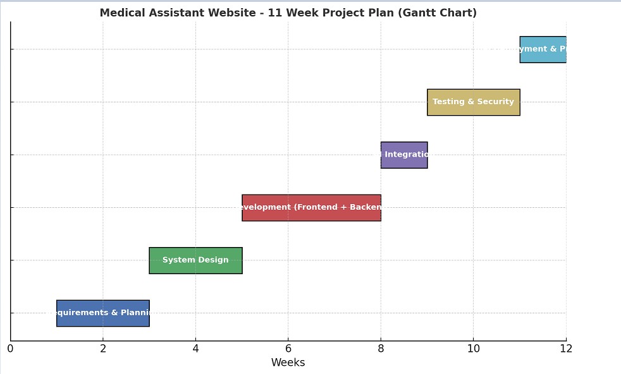
The project will be completed in 11 weeks, divided into the following phases:
-Weeks 1–2: Requirements gathering & project planning.
-Weeks 3–4: System design & architecture.
-Weeks 5–7: Website development (frontend + backend).
-Week 8: AI symptom checker & reminder system integration.
-Weeks 9–10: Testing, bug fixing, and security checks.
-Week 11: Final deployment & project presentation.

2. Milestones
- End of Week 2: Requirements finalized.
-End of Week 4: Design completed.
- End of Week 7: Functional prototype ready.
- End of Week 8: AI features integrated.
- End of Week 10: Testing completed.
-Week 11: Final project launch.

3. Deliverables
-Requirements document.
-System design diagrams (architecture, database schema, UI mockups).
-Responsive website prototype.
-AI-based symptom checker & reminders.
-Final report and presentation.

4. Resources
-Budget: Hosting, domain, and AI integration tools.
-Tools: VS Code, Figma, GitHub, MySQL, Python (AI), HTML/CSS/JS.
-People: Supervisor Engineer: Sarah
Frontend Developer: [Team Member 1]
Backend Developer: [Team Member 2]
AI Specialist: [Team Member 3]
Tester: [Team Member 4]

3. Task Assignment & Roles
1. Supervisor Engineer (Sarah)
- Task: Oversight and project guidance.
- Responsibility: Ensure project aligns with objectives, review deliverables, provide technical and managerial supervision.

2. Frontend Developer
- Task: Build the user interface.
- Responsibility: Design and implement responsive web pages, ensure good user experience, integrate UI with backend APIs.

3. Backend Developer
- Task: Develop server-side logic and database.
- Responsibility: Set up databases, build APIs, manage authentication, and ensure secure data handling.

4. AI Specialist
- Task: Implement AI features.
- Responsibility: Develop and integrate the AI-powered symptom checker, reminders, and ensure accuracy of AI outputs.

5. Tester
- Task: Quality assurance and testing.
- Responsibility: Conduct functional, usability, and security testing, report bugs, and verify fixes before deployment.

4-Risk Assessment & Mitigation plan:
1. Risk: Delay in Development Timeline
-Possible Issue: Some tasks (AI integration or backend APIs) may take longer than expected, leading to project delays.
-Mitigation: Break tasks into smaller milestones, apply weekly progress checks, and reallocate team members temporarily if delays occur.

2. Risk: Data Privacy & Security Concerns
-Possible Issue: Handling sensitive medical data could raise risks of breaches or unauthorized access.
-Mitigation: Implement strong encryption, secure authentication, regular vulnerability testing, and follow data protection best practices.

5. KPIs (Key Performance Indicators)
1. Response Time
-Metric: Average time for the system to respond to user requests (symptom checker, appointment booking).
-Target: Less than 2 seconds for main features.

2. System Uptime
-Metric: Percentage of time the website is available and fully operational.
-Target: 99% uptime during the project evaluation period.

3. User Adoption Rate
-Metric: Percentage of target users (patients/doctors) who actively use the platform after launch.
-Target: At least 70% of invited users engage with the system within the first month.

